**Introduction**

Dudepanda is a simple ecommerce marketplace of bakeries located in karachi. Customers can save themselves from the hassle of going to the bakery and buying items rather place an order through this website and get it delivered directly to their place like ordering a birthday cake for their loved ones.

The following report attempts to list down the steps taken in order to create this project. The members who’s efforts pulled off this project are Hasan Naseem, Faraz Ozair and Hozefa Haider.

The website required a database which would essentially contain the data of All the Vendors, Customers, Food items, Orders etc. So the first job was to decide and create an entity relationship diagram (ERD) that would form the basis of our Database.

**ERD;**

Following is a picture of our ERD;

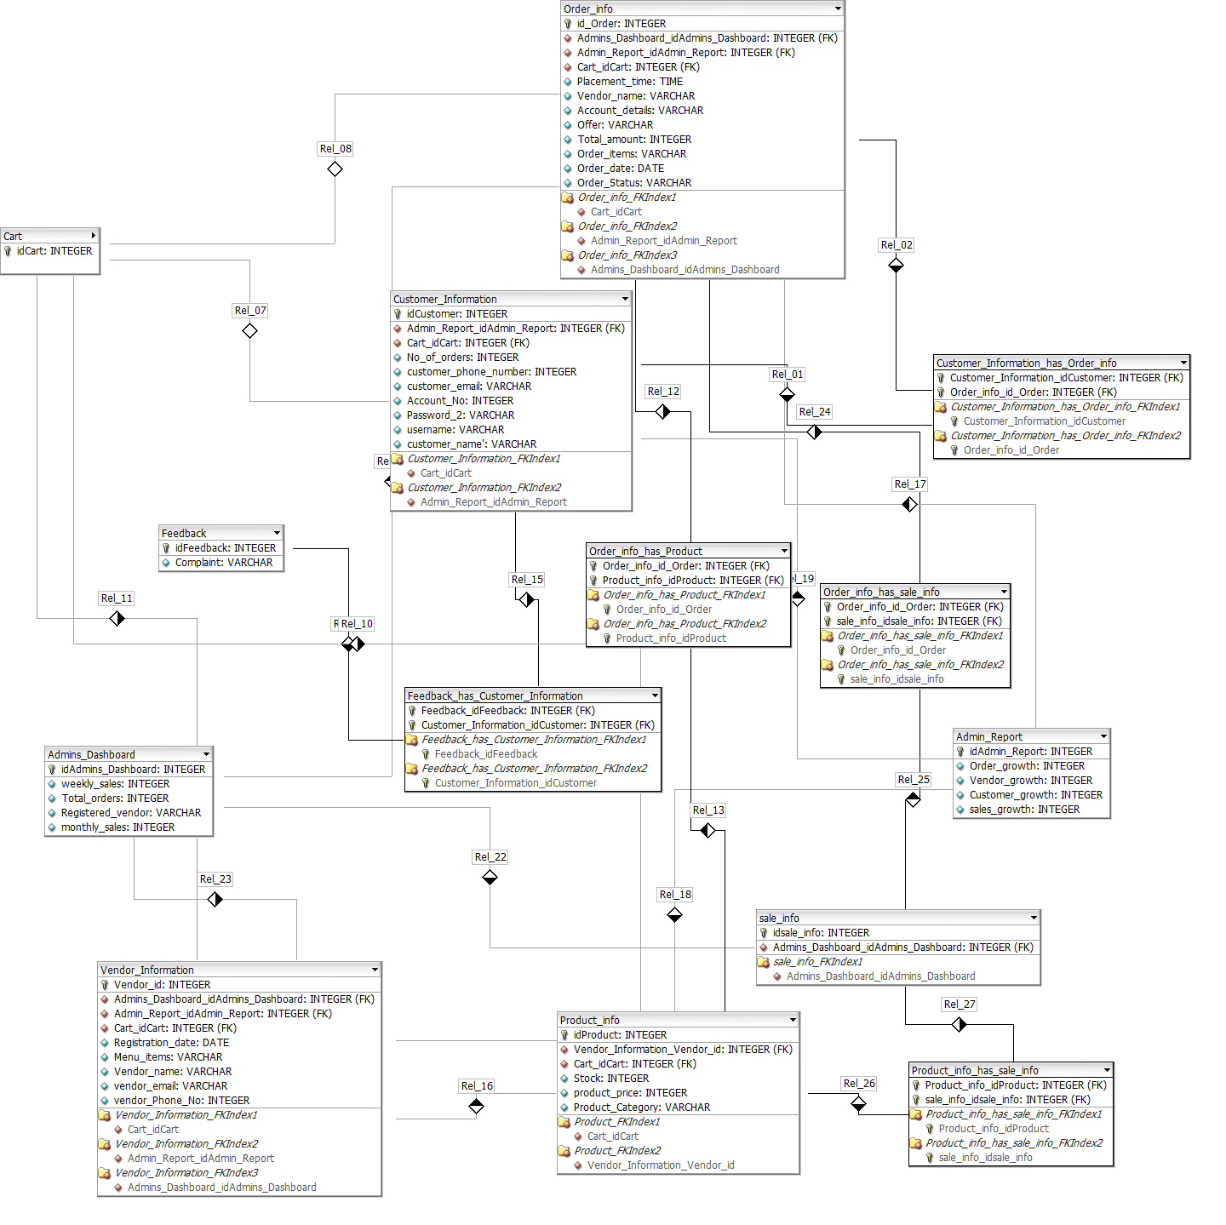

The entities in this ERD are **Admins Dashboard, Vendor Information, Customer Information, Admin Report, Product_Info, Cart,Order_Info, Feedback**

Following is the description of the entities and the relationships between them:

-**Admins Dashboard**;

This Table will show the registered Vendors and the Total number of Orders, weekly and monthly sales, of these Vendors both of which will be derived from daily sales(which itself- will be a derived quantity, sum of sales of a particular day). This table will allow the admin to have an overall picture of the Vendor Performances which will be reflected by their Orders and Sales and also reflect the Company’s performance as well.

-**Vendor Information**

This table will contain the list of Vendors registered with the Company. Each Vendor has certain attributes such as Vendor name, phone no#, Registration date etc. Each Vendor is assigned a Vendor ID by the Company

- **Customer Information**

Customer info will contain the details of the users that have signed up on the website whether or not they use the application or not. This table contains the users account details (account# , password, username) and other details such as phone number, email address and of course the name of the Customer. Each Customer is assigned a Customer ID by the company at the time when the Customer creates an account

-**Admin Report**

Admin Report and Admins Dashboard are related to each other in the sense that both of them give an overall picture of the Company’s Performance. However the table of Admin Report gives a more concrete and statistical analysis of the Company’s Performance as the attributes it holds are essentially all in numbers; Order growth, Vendor growth, Customer growth, sales growth.

-**Product Information**

Product Information will display the Menu of the Different Vendors. Each Product is assigned a Product ID by the Company

**-Cart**

Each Customer will have its own Cart (and hence a seperate ID assigned by the Company) which will hold information about the order.

-**Order Information**

This table will contain the information about the details of a particular order placed by a customer, including its placement time. Each order will have a distinct ID assigned by the Company.

-**Feedback**

Customers will be reviewed about their experiences regarding their usage and satisfaction. This table will contain all that data

**Relationships:**

-**Admin Dashboard**

* 1:n relationship with Order_info table since the admin will have access every order information from the customer. E.g. quantity, item name, item ID etc. Similarly, many order informations will be managed by the same admin.
* 1:n relationship with Sale_info table since every sale done of a particular item will be managed by the admin and a single admin will have many sale_info at a particular time. Similarly, many sales will be managed by the admin as well.
* 1:n relationship with the Vendor_information because the admin will also have many vendors at a particular time and he will be managing all the vendor items and will have the vendor information incheck with him. Similarly, many vendors could have the same admin.

-**Vendor Information**



(prestashop setup) hozefa

(sample data) faraz

The sample data that we have integrated in our website to show the functionalities are the following:

(how database integrated into prestashop) hozefa